Workplace Email Templates
Email 1a: Campaign Welcome and Kick-Off


Subject Line: Leading the Way in Kenosha County
Preheader Text: In our community, everyone deserves the opportunity to thrive.
Email Body:
[Name],
Join [Company Name] in leading the way for a better future for all by donating today.
Your support of United Way of Kenosha County, will allow us to advance health, youth opportunity, financial security to ensure our neighbors can thrive. The impact of United Way is powered by generous supporters, like you, who are committed to #LeadingTheWay to a stronger community.
Because of your generous support, United Way of Kenosha County is making a difference in the lives of over 9,000 people each year. We need you with us. Starting [insert date], join us in Leading the Way to a better future for all.
If you have any questions about the campaign, please contact [insert employee campaign coordinator name and contact information].
Closing,
Signature

Email 1b: Company CEO variation/Campaign Launch Day
Subject Line: [Company Name] is Leading the Way in Kenosha County
Preheader Text: In our community, everyone deserves the opportunity to thrive.
Email Body:
[Name],
United Way of Kenosha County supports the needs of our community every day to help strengthen our community to ensure everyone will thrive. Join me in leading the way for our community by participating in this year’s campaign. We’ve set an ambitious goal of raising [monetary goal/description] to help do just that.
I believe that when we come together as a team, there’s no challenge that can’t be solved. That’s why I’m inviting you to join me in Leading the Way toward positive change in Kenosha County. This is more than a campaign – it is a call to action for us at [Company Name] to advance solutions to real problems facing people in the communities where we live and work.
Together, we can advance health, youth opportunity, financial security and strengthen overall community resilience to build a future where everyone can reach their full potential. We’re counting on generous people like you and your teammates to help improve the lives of people in our community. Last year, United Way of Kenosha County was able to provide over $150,000 to deserving local nonprofits and support over 9,000 individuals and families. And this year, with your help, we know that we can do even more.
BUTTON TEXT: LEAD THE WAY [Hyperlink to Campaign Webpage]
I want to thank you in advance for your valuable support and for Leading the Way here at [Company Name].
[Closing],
Signature/Name of Company CEO

Reminder Emails
Email 3a: Reminder #1
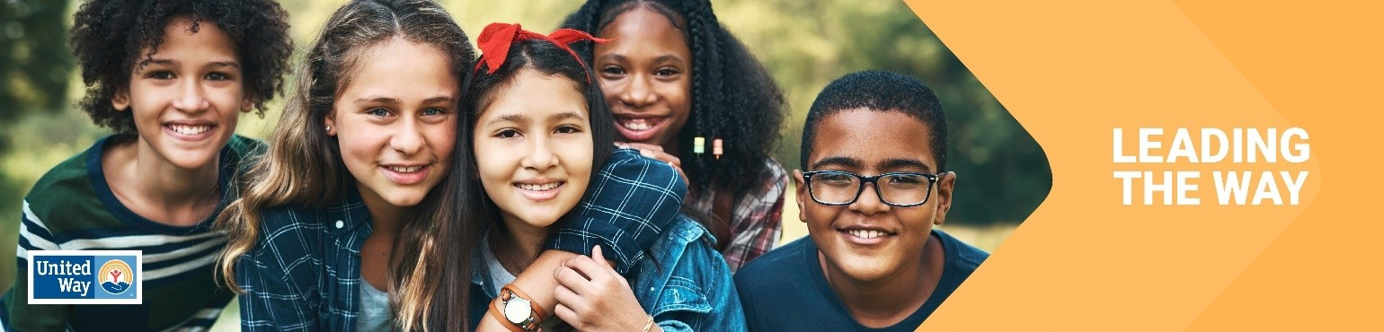
Click here for the Canva template

Subject Line: What are we doing together in [Anytown]?
Preheader Text: Mobilizing our community and changing lives.

Email Body:

Hi [Name],
We need you with us-- whether you’re new to United Way of Kenosha County or you’ve been creating impact with us for years.
At United Way, we believe that everyone who lives and works in Kenosha County deserves the opportunity to thrive. Together with you, United Way mobilizes the caring power of people to create transformational change here in Kenosha County.
Day in and day out, United Way of Kenosha County funds/supports/leads/develops] programs that meet the most urgent needs in our community. We’re proud of all we’ve accomplished together for our great community:

[Add specific successes for your United Way. This can be from all aspects of your work, or if the company is more focused on education and youth, highlight your programs and results in that area. If you have photo releases, adding a picture is always a nice touch!]
More work is needed to build on this momentum. If you’ve already given, thank you. If you haven’t, there’s still time to join in.
BUTTON TEXT: Donate [Hyperlink to Campaign Webpage]
Together, let’s Lead the Way and make great things for people who call Kenosha County home.
[Closing],
Signature

Email 3b: Reminder #2
Click here for the Canva template

Subject Line: How United Way and [Company Name] are Leading the Way
Preheader Text: Partnered up to create real impact
Email Body:

Dear [Name],
We want to take a moment to celebrate how United Way of Kenosha County and [Company Name] are partnering to change lives in our community.

[This email should be tailored to United Way’s relationship with the company. For example,
- Highlight the number of years a company has been a sponsor
- Highlight the impact the company has had during Day of Caring and/Read Across Kenosha—the # of hours, the value of that volunteer service to the community. How United Way has helped deepen the company culture around service. Add photos from Day of Caring/Read Across Kenosha, if you have releases.
- Highlight an employee volunteer such as a Readers Are Leaders or Volunteer Income Tax Assistance volunteer
Let’s build on [Company Name]’s legacy to do even more. Donate today to Lead the Way to a better future for Kenosha County.

BUTTON TEXT: Donate [Hyperlink Campaign Website]
[Closing],
Signature

Email 3c: Reminder #3 or Final Reminder
Click here for the Canva template

Subject Line: Time is running out to Lead the Way
Preheader Text: Tick, tock…
Email Body:

Have you donated yet to Lead the Way in Kenosha County?

From strengthening local resilience to advancing health, youth opportunity, and financial security, your support is integral to creating impact in our community. Employees at [Company Name] are chipping in and Leading the Way to a better future for everyone in Kenosha County.
BUTTON TEXT: Donate [Hyperlink to Campaign Webpage]
Thank you for your continued support!
[Name],
[Closing],
Signature

Email 4a: End of campaign
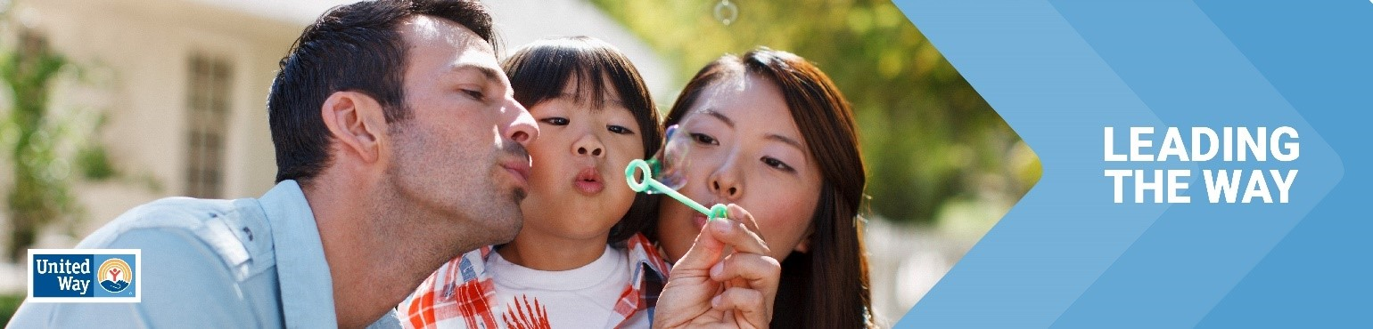
Click here for the Canva template

Subject Line: Thank you for Leading the Way in Kenosha County
Preheader Text: [intentionally left blank]
Email Body:

Dear [Name],

Join me in celebrating the success of [Company Name’s] efforts to Lead the Way by changing lives in Kenosha County.

I’m thrilled to report: [customize]

[Company Name] employees gave $ [dollars pledged] to United Way of Kenosha County
[participation rate%] of [Company Name] Employees gave to United Way of Kenosha County
[number of donors] of [Company Name] employees gave to United Way of Kenosha County
[Company Name] employees contributed more than [number of volunteer hours] volunteer hours during the campaign.

Together, our collective impact is creating a better future for youth, families and communities in Kenosha County. Thank you for Leading the Way!
[Closing],
Signature

